Meshack Nyagwencha Bosire IVF370

Lab 05

H. cd S. cd R. bd R cd S. cd H

H. cd H cd R. bd R cd H cd H

Key

H - Hub

S - Switch

R - Router

bd - broadcast domain.

cd - collision domain.

4.1

A)

Collision domains: 4

Broadcast domains: 3

B)

Collision domains: 3

Broadcast domains: 5

4.2

After configuring the IP address using the ifconfig command, the routing table will not be empty. It will have at least one entry, which is the network that the IP address belongs to. This is because when you assign an IP address to an interface, the system automatically creates a route for the network that this IP address belongs to.

B)

Routing is a two-way process. For communication to be successful and effective, both nodes need to know the route to each other.

C)

Yes,

The default gateway is the node that the network uses to send packets to other networks. In this case, any packet with a destination outside the 10.0.4.0/24 network would be sent to the default gateway for further routing.

4.3)

A) Here are the obtained subnets along with their netmasks:

1. Subnet 1: 84.8.232.63/26 with a netmask of 255.255.255.192
2. Subnet 3: 84.8.232.128/26 with a netmask of 255.255.255.192
3. Subnet 4: 84.8.232.192/26 with a netmask of 255.255.255.192
4. Subnet 5: 84.8.232.0/2]6 with a netmask of 255.255.255.192

B) Yes, it is possible to refer to the first 4 subnets all together. You can do this by using a larger subnet that encompasses all 4 subnets. In this case, you can use the 192.168.1.0/26 subnet, which includes all addresses from 84.8.232.0/26 to 84.8.232.192/26, thus covering the first 4 subnets. Please note th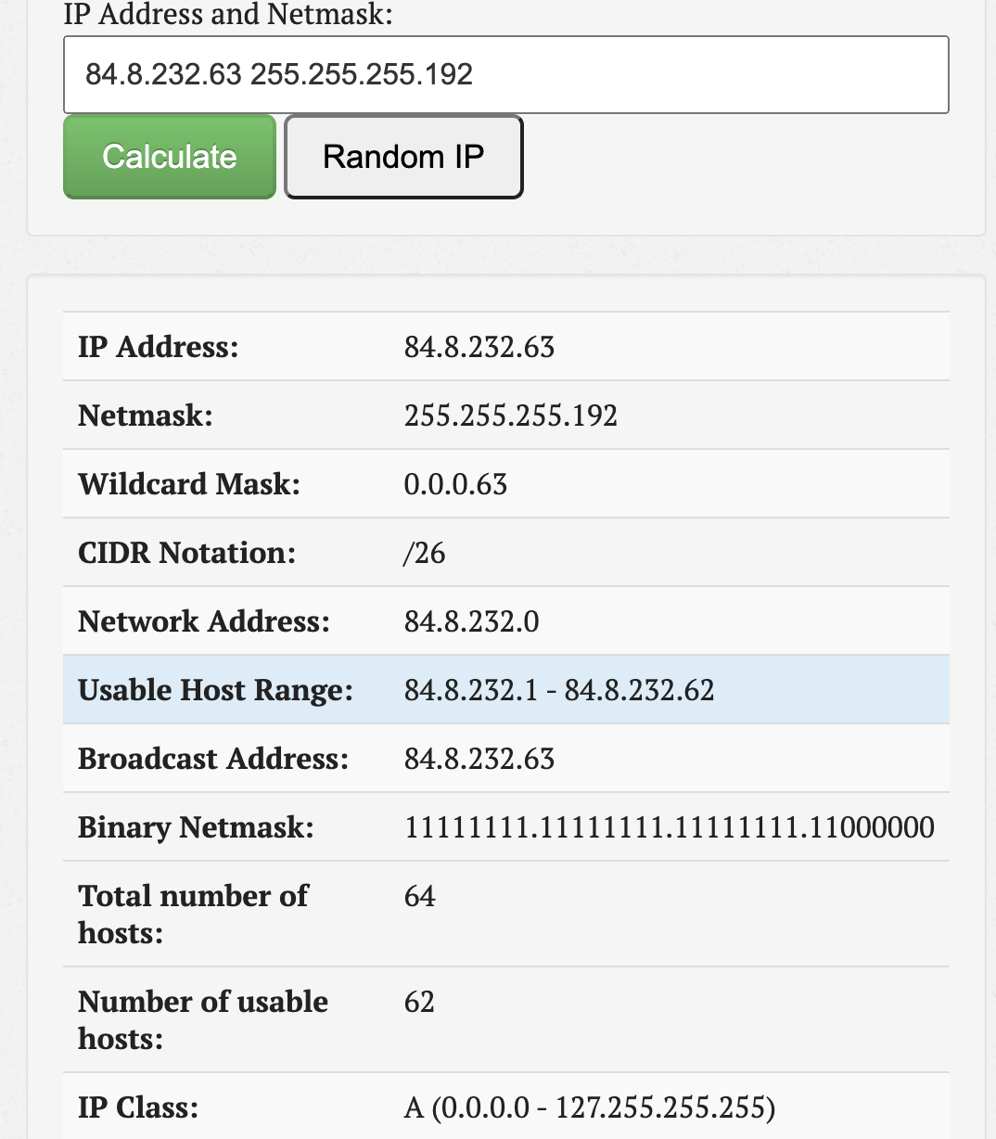at this is for reference purposes only and doesn’t change the actual configuration of the individual subnets.

4.4

A)

1. Subnet 1: 172.16.0.0/19 with a netmask of 255.255.225.0
2. Subnet 2: 172.16.32.0/21 with a netmask of 255.255.248.0
3. Subnet 3: 172.16.40.0/20 with a netmask of 255.255.240.0
4. Subnet 4: 172.16.56.0/21 with a netmask of 255.255.248.0

B) What happens if the requirements arrive with a bigger difference in time, i.e. subnetting has to be performed in the order of entering routes in the routing table?/

 If the requirements arrive with a bigger difference in time, i.e., if the subnets are not all known at the start, then the subnetting would need to be performed in the order of the requirements. This could potentially lead to inefficient use of the IP address space, as you might end up with a situation where you cannot satisfy a later requirement because the address space has been used up by earlier subnets.

C) How many nodes approximately left from the initial network with a thousand precision which can be used?

The initial network with a prefix length of /16 has 2^(32-16) = 65,536 addresses. After subtracting the addresses used by the four subnets (8192 for subnet 1, 2048 for subnet 2, 4096 for subnet 3, and 2048 for subnet 4), and considering that each subnet uses 2 addresses for the network and broadcast addresses, we have approximately 65,536 - (8192 + 2048 + 4096 + 2048) - 4\*2 = 48,128 addresses left. So, approximately 48,000 addresses are left with a thousand precision.

D) What is the size of the biggest subnet/network which can be used from the remaining host addresses?

The size of the biggest subnet/network that can be used from the remaining host addresses would be a /17 subnet, which provides 2^(32-17) = 32,768 addresses (32,766 usable). This is because 32,768 is the largest power of 2 that is less than the number of remaining addresses (48,128).